

Android Bootcamp Challenge One

# Part 1 - Kotlin Basics

Watch the video series [Kotlin Basics](https://www.raywenderlich.com/7910496-programming-in-kotlin-fundamentals) and for practice try the challenges. To practice what you learned, create the following program in Kotlin.

## Deal and Evaluate an Initial Hand of Blackjack

Blackjack is a game played with regular playing cards. Playing cards consist of a ‘pip’, the numeric or face value of the card, and a suit. Initially, the player receives two cards in a hand. The goal of the game is for the cards’ pip total to equal and not exceed 21. Face cards are counted as 10, Aces as 11 and the other cards as their numeric pip value. You will create a subset of this game that deals and evaluates the first two cards from a deck. Create a program that creates a deck of cards, deals two cards from that deck into a hand and evaluates that hand of cards by finding the sum of the pips. Display the cards in the hand and the total of the pips in the hand. Utilize classes, collections and functions.

## A Suggested Approach

### Card Class

Create a data class called Card that contains two members, a String for the pip and a Char for the suit.

### createDeck Function

Create a function that creates a collection of suits and a collection of pips. Use a nested for loop to create a card of each pip for each suit and place it in a MutableSet<Card>. Return the MutableSet of cards.

You can use regular letters C, S, D, H or unicode characters for the suit.

'\u2663' - club

'\u2660' - spade

'\u2666' - diamond

'\u2665’ - heart

### dealHand Function

Create a function that can deal two cards from the deck. This function should receive the MutableList<Card> deck as a parameter as well as the number of cards it should place in the hand. It should return a collection containing the number of cards specified. **Note:** You can use the random function on collections:

val card = deck.random()

Then you can remove the card from the deck:

deck.remove(card)

### evaluateHand Function

Create a function that receives the hand as a parameter. Utilize a decision statement such as an if statement or a when statement to figure out the pip value of the card and add it’s value to a total. This function should return the total.

### printResults Function

This function should receive the total and the hand as a parameter. It should print the cards in the hand in a readable way, and then print the total of the hand. The final output of the game should look like:

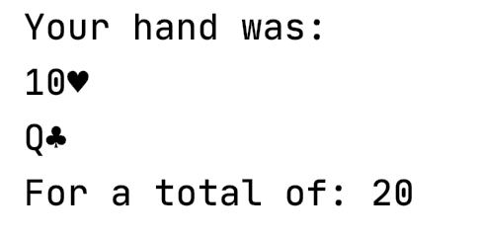

The total must be correct and the cards must be unique. If the total happens to be 21, then it’s a lucky player, print the message ‘You Win!’ below the total. If the user gets two aces, counting aces as 11 the hand has a total of 22, print ‘You Lose!’ below the total.

You can deviate from my suggestions above to a reasonable point but for full credit this program must utilize at least one class, at least one type of collection, and multiple functions.

# Part 2 - Turn in Your Project using Git

If you would like a primer in git see the [Beginning Git](https://www.raywenderlich.com/4418-beginning-git) course or if you’d like to know even more about git, see the [Mastering Git](https://www.raywenderlich.com/488-new-course-mastering-git) course.

Create a directory or use your project directory and create a new git repo in that directory utilizing the tool of your choice. Include your .kt code file in the directory. Be sure to also include a README.md file that contains a bio including:

* Your name
* Your Discord Username
* Basic Location (Country, State/Province or City)
* Your programming experience
* Goals and/or Hobbies and Interests

Use markdown to create your README.md file and embed a photo of yourself in it with your bio. [Here’s](https://guides.github.com/features/mastering-markdown/) a guide if you’re new to markdown. Do an initial commit and push the repo to your github account. You can sign up for one if you don’t already have one. To submit this assignment, please email the link to your github repo to your mentor.

Filip: [filip@razeware.com](mailto:filip@razeware.com)

Fuad: [fuad@anaara.com](mailto:fuad@anaara.com)

Luka: [mrluka9@gmail.com](mailto:mrluka9@gmail.com)

Jenn: [reddunrogue@gmail.com](mailto:reddunrogue@gmail.com)